Exercise 3: Stored Procedures

Scenario 1: The bank needs to process monthly interest for all savings accounts.

Question: Write a stored procedure ProcessMonthlyInterest that calculates and updates the balance of all savings accounts by applying an interest rate of 1% to the current balance.

SOLUTION SCRIPT

CREATE OR REPLACE PROCEDURE ProcessMonthlyInterest IS
BEGIN
FOR RECORD IN (
SELECT CUSTOMERID FROM CUSTOMERS
FOR UPDATE
) LOOP
UPDATE CUSTOMERS
SET BALANCE = BALANCE + BALANCE * 0.01
WHERE CUSTOMERID = RECORD.CUSTOMERID;
END LOOP;

COMMIT;
END;
/

-- or

CREATE OR REPLACE PROCEDURE ProcessMonthlyInterest IS
BEGIN
UPDATE CUSTOMERS
SET BALANCE = BALANCE + BALANCE * 0.01;

COMMIT;
END;
/

BEGIN
ProcessMonthlyInterest;
END;

OUTPUT
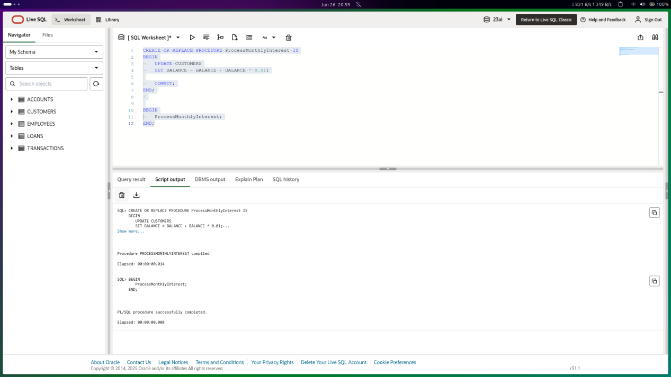
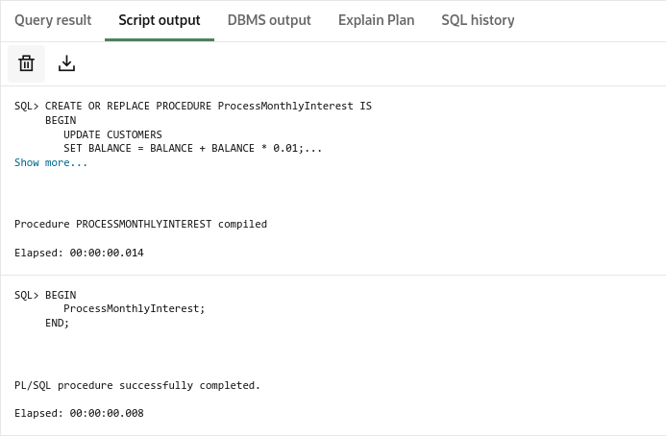

Scenario 2: The bank wants to implement a bonus scheme for employees based on their performance.

Question: Write a stored procedure UpdateEmployeeBonus that updates the salary of employees in a given department by adding a bonus percentage passed as a parameter.

SOLUTION SCRIPT

CREATE OR REPLACE PROCEDURE UpdateEmployeeBonus (
dept_name IN VARCHAR2,
bonus_percent IN NUMBER
) IS
BEGIN
FOR RECORD IN (
SELECT EMPLOYEEID FROM EMPLOYEES
WHERE DEPARTMENT = dept_name
FOR UPDATE
) LOOP
UPDATE EMPLOYEES
SET SALARY = SALARY + SALARY * (bonus_percent/100)
WHERE EMPLOYEEID = RECORD.EMPLOYEEID;
END LOOP;

DBMS_OUTPUT.PUT_LINE('Bonus added to ' || dept_name || ' Employees!');
END;
/

BEGIN
UpdateEmployeeBonus(dept_name => 'IT', bonus_percent => 10);
END;

OUTPUT
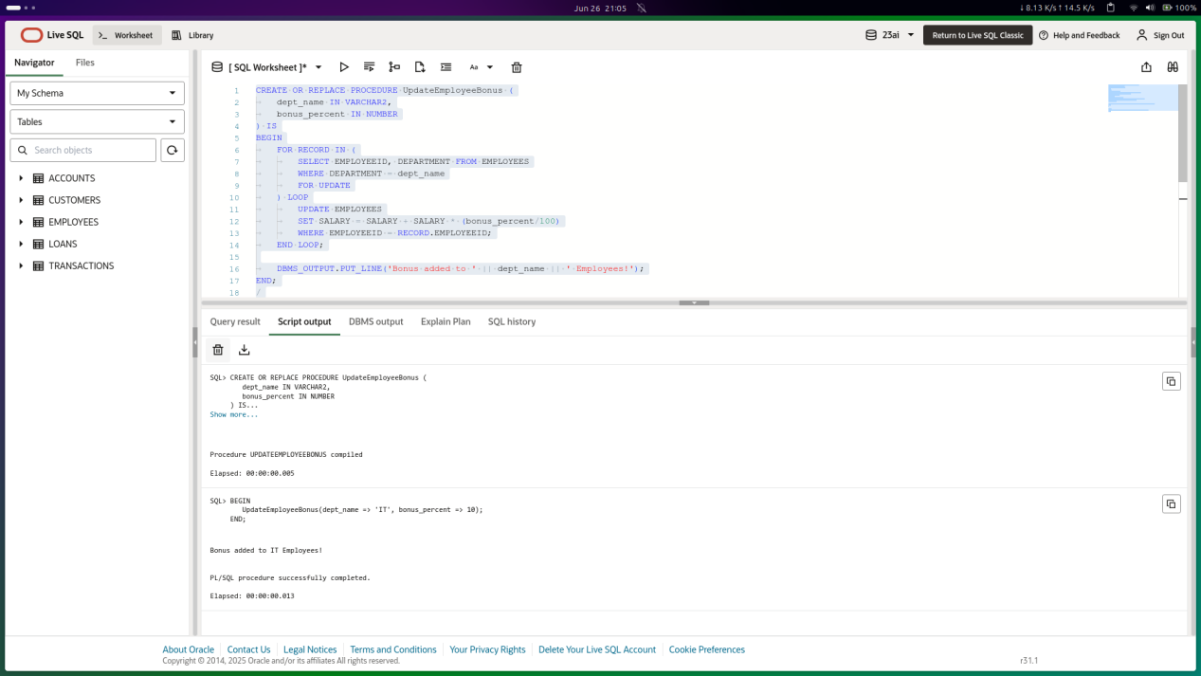
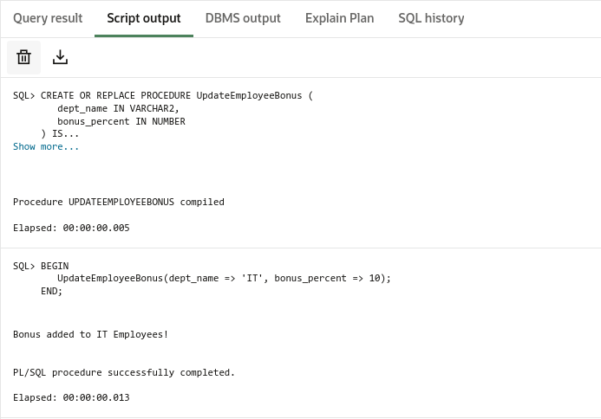

Scenario 3: Customers should be able to transfer funds between their accounts.

Question: Write a stored procedure TransferFunds that transfers a specified amount from one account to another, checking that the source account has sufficient balance before making the transfer.

SOLUTION SCRIPT

CREATE OR REPLACE PROCEDURE UpdateEmployeeBonus (
dept_name IN VARCHAR2,
bonus_percent IN NUMBER
) IS
BEGIN
FOR RECORD IN (
SELECT EMPLOYEEID FROM EMPLOYEES
WHERE DEPARTMENT = dept_name
FOR UPDATE
) LOOP
UPDATE EMPLOYEES
SET SALARY = SALARY + SALARY * (bonus_percent/100)
WHERE EMPLOYEEID = RECORD.EMPLOYEEID;
END LOOP;

DBMS_OUTPUT.PUT_LINE('Bonus added to ' || dept_name || ' Employees!');
END;
/

BEGIN
UpdateEmployeeBonus(dept_name => 'IT', bonus_percent => 10);
END;

OUTPUT
